DVK 3.1 Programmer's Guide
29th of January 2019 [software version: Linux kernel 4.9.88]

Table of Contents
1 Introduction 4
2 M3-IPC Fundamentals 4
2.1 Architecture 4
2.2 Kernel Patch, Kernel Modules, Libraries, Proxies, Sample Code and Micro-Benchmarks 5
2.3 Distributed Containers and Linux Containers 6
2.4 Messaging Overview 7
2.4.1 Special M3-IPC endpoints 7
2.4.2 Endpoint Types 7
2.4.3 Endpoint Resolution 8
3 Minix emulated IPC APIs 10
3.1 Minix IPC functions 10
3.1.1 Message types 11
3.1.2 dvk_send(), dvk_reply() 11
3.1.3 dvk_receive(), dvk_rcvrqst() 12
3.1.4 dvk_sendrec() 13
3.1.5 dvk_notify() 14
3.1.6 dvk_vcopy() 14
4 DVK Management dvk_calls 16
4.1 Overview 16
4.1.1 dvk_open() 16
4.1.2 dvk_dvs_init() 16
4.1.3 dvk_dvs_end() 18
4.1.4 dvk_getdvsinfo() 18
4.1.5 dvk_dc_init 18
4.1.6 dvk_dc_end 19
4.1.7 dvk_getdcinfo() 19
4.1.8 dvk_bind() 20
4.1.9 dvk_wait4bind()/dvk_wait4unbind() 21
4.1.10 dvk_unbind() 22
4.1.11 dvk_getep() 23
4.1.12 dvk_getprocinfo() 23
4.1.13 dvk_setpriv() 23
4.1.14 dvk_getpriv() 24
5 Proxies and Remote Nodes 25
5.1 Proxies and Nodes dvk_calls related overview 26
5.1.1 dvk_proxies_bind() 26
5.1.2 dvk_proxy_conn() 26
5.1.3 dvk_proxy_unbind() 27
5.1.4 dvk_getproxyinfo 28
5.1.5 dvk_add_node() 29
5.1.6 dvk_ getnodeinfo() 29
5.1.7 dvk_del_node() 30
5.1.8 dvk_node_up() 30
5.1.9 dvk_node_down() 30
5.1.10 dvk_get2rmt() 31
5.1.11 dvk_put2lcl() 32
6 Fault Tolerance and Process Migration 33
6.1.1 dvk_migr_start() 36
6.1.2 dvk_migr_commit() 37
6.1.3 dvk_migr_rollback() 37
7 Integration with Linux /proc filesystem 39
8 How to start a DC ? 43
9 How to run a process inside a DC? 44
10 Source Code Organization 45
10.1 How to add a new dvk_call 45
10.1.1 dvs/include/com/dvk_calls.h 46
10.1.2 dvs/include/com/dvk_ioctl.h 46
10.1.3 dvs/include/com/stub_dvkcall.h 46
10.1.4 dvs/dvk-mod/dvk_ioproto.h 46
10.1.5 dvs/dvk-mod/dvk_newproto.h 46
10.1.6 dvs/dvk-lib/stub_dvkcall.c 46
10.1.7 dvs/dvk-mod/dvk_decode.c 47
10.1.8 dvs/dvk-mod/dvk_decode.c 47
10.2 Kernel and Module Compilation and Deployment 48

Introduction
This document is intended to assist software developers to write Virtual Operating Systems (VOS) or applications for a Distributed Virtualization System (DVS). A component of the DVS is the Distributed Virtualization Kernel (DVK) which provides Minix 3 InterProcess Communication integrated in the Linux kernel as a module. M3-IPC has several enhancements such as to communicate transparently local and remote processes, to support virtual execution environments for IPC containment, to support the Primary/Backup and State Machine replication approaches and to allow communications on process migration.

M3-IPC Fundamentals
M3-IPC are Inter-Process Communications APIs that emulates Minix 3 IPC ones. A Linux process can use these primitives in the same way as it was a Minix process.
Some extra functionalities were added:
- It supports different virtual execution environments called Distributed Containers (DC) where Linux processes can communicate between them using M3-IPC without interferences with other Linux processes of other DCs. Now, a DC is integrated with Linux Namespaces, Control Groups and Capabilities conforming Linux Containers.
- It supports message and data block transfers among processes located in the same or in different nodes of a DVS cluster in a transparent way.
- It supports the Primary/Backup replication approach where a process called the Primary is the active process, and could be several passive processes called Backup. When the Primary fails, one of the Backup processes switches as a Primary and remains the service active.
- It supports the State Machine replication approach where a group of processes provide a service to clients. All processes are active, and when one or more of then fail, the other processes remain providing the service.
- It supports communication continuity on process migration. When one process migrates from one node to another, the communications remains once the process has migrated or not.
A brief summary of the major concepts used in the DVK is provided in the following sections.

Architecture
M3-IPC is as a component of the Distributed Virtualization Kernel (DVK) which is the foundation of a Distributed Virtualization System (DVS). A DVS is a kind of SSI virtualization system which support OS system level DCs. In a DVS cluster (Fig. 1), processes of a DC can expand to multiple computers (aggregation) or DVS nodes, and multiple processes of different DCs can run on the same DVS node (partitioning).
Before the M3-IPC facilities can be used, the DVS must be started in each node using dvk_dvs_init() specifying some parameters as the maximum number of DCs that can be configured in the DVS.

Kernel Patch, Kernel Modules, Libraries, Proxies, Sample Code and Micro-Benchmarks
The DVK is distributed as a kernel patch and a kernel module for Linux kernel 4.9.88, and must be loaded before running any process which uses its APIs. If a dvk_call is invoked without the kernel module loaded an EDVSNOSYS error will be returned.
To load the kernel module, a user logged as root must execute:
cd /usr/src/dvs/dvk-mod
mknod /dev/dvk c 33 0
insmod dvk.ko dvk_major=33 dvk_minor=0 dvk_nr_devs=1

To verify the correct module load, the user can do:
#lsmod
#dmesg

The DVK provides a library to build management and production VOSs and Applications. It also provides TCP, UDP and TIPC proxies to communicate DVS cluster nodes and a lot of sample test code and micro-benchmarks.
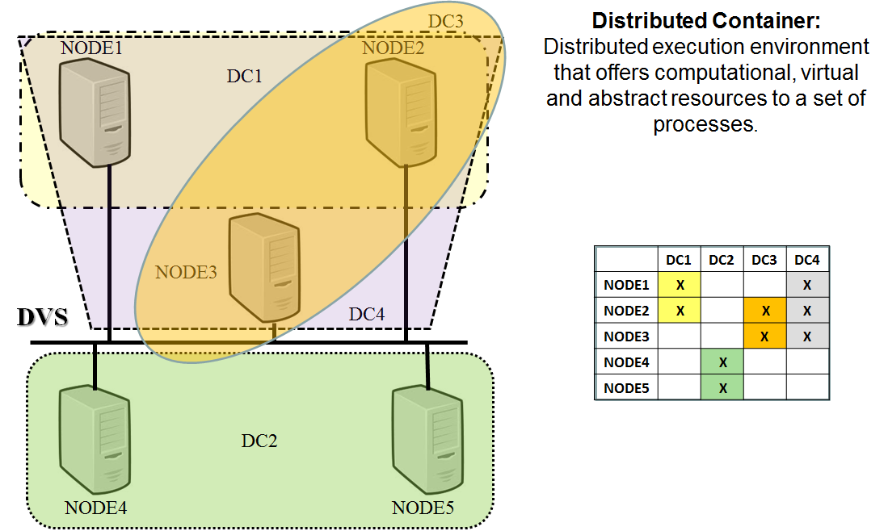
- DVS Cluster Topology.

Distributed Containers and Linux Containers
Really, Linux does not have Containers by itself, but it has all the tools needed to build them. The Linux kernel provided components are:
- Control Groups (CGROUPS): They allow to allocate and to limit Linux kernel resources for a group of processes (CPU time, memory, networking, etc).
- Namespaces: They allow to allocate name spaces to a group of processes (PIDs, mount, network, user, etc).
- Capabilities: They allow to allocate different execution privileges to process.

This version of the DVK integrates Distributed Containers with a group of so called Linux Containers (LC). A DC conforms an M3-IPC namespace which limits message and data transfers between processes belonging to the same DC. Additionally, a DC is a set of LCs with one LC defined in each node were the DC is expanded to.
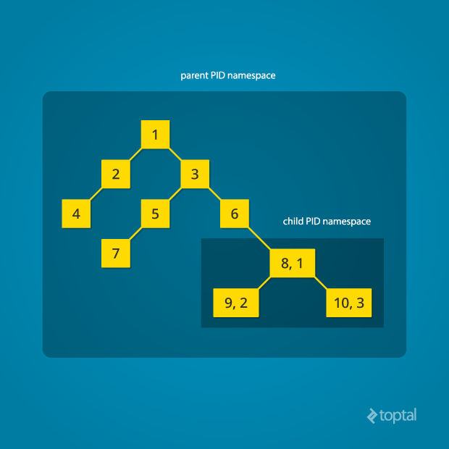
- Linux PID namespaces.
When a process runs inside a DC, really it is running inside an LC in its host, therefore as the LC namespace of the DC differs from the init LC (the DC when the system boot), some identifiers as the PID of a process will be really a Virtual PID, not the Global PID in the init namespace. The same things occur with the mount, network o user namespaces.
https://www.toptal.com/linux/separation-anxiety-isolating-your-system-with-linux-namespaces
https://uwsgi-docs.readthedocs.io/en/latest/Namespaces.html

Messaging Overview
M3-IPC applications typically communicate each other by exchanging data units, known as messages, between registered processes identified by their endpoints. The endpoint number could be a positive, zero or negative integer allocated by a process with DC/VOS capabilities. As endpoint are inherited from Minix, they are compose by two fields: <endpoint>:= <generation><proc_nr>. An endpoint number allows to identify the proc_nr, which is number that identifies a VOS process descriptor slot. Several endpoints could identify the same proc_nr, but they differ on the generation field. The generation field is used by the VOS to discard messages delivered to death processes which hold the same process descriptor (p_nr).
Warning: The DVK do not check the generation number allocated for an endpoint. Only use the endpoint number to get the proc_nr and reverse. It is a VOS or application responsibility to control the generation number.
From an application's perspective, a message is a fixed byte string with a structure defined in “dvs/include/com/ipc.h” but, the use of the fields is determined by the applications.
A Distributed Container (DC) is an execution environment for a set of Linux processes that can exchange messages. Each DC is identified by a dcid. An endpoint identifies an entity that can send and receive messages within a DC, therefore the same endpoint number can exist in different DCs.
Linux processes can only use M3-IPC primitives if they are register to the DVK using the dvk_bind() dvk_call. As a result, it returns the process (or thread) endpoint that identifies it to other processes running in the same DC.
Main IPC are performed using the rendezvous message passing. Rendezvous means that the sender is blocked until the receiver actually receives the message, or it blocks the receiver until the sender actually sends to it the desired message. This behavior is also called synchronous, but the DVK also provides timed and asynchronous IPC dvk_calls.

Special M3-IPC endpoints
As in Minix, M3-IPC has special endpoints.
- ANY: used to indicate 'any process' (can only be used in dvk_receive())
- NONE: used to indicate 'no process at all'
- SELF: used to indicate ‘self process'

Endpoint Types
As M3-IPC can transfer message and data among processes on different nodes of a network in a transparent way, endpoint can be:
- Local: Identifies a process or thread running in the local node. Each Local endpoint is linked to the PID of a process/thread in the Linux host.
- Remote: Identifies a process or threads running in a remote node. Each Remote endpoint has not a Linux PID, but is linked to the DVS node where the Remote process runs. A Local process can receive or send messages/data to/from a Remote process in the same way as it is Local.
- Backup: Identifies a process or thread running in the local node. Each Backup endpoint is linked to the PID of the process in the Linux host and to the node of Remote endpoint which is considered the Primary. It cannot send/receive any message/data until it is promoted as a Local endpoint. Meanwhile, it behavior is the same as a Remote endpoint. It is used for implementing Primary-Backup strategy replication and to migrate process among nodes.
- Replica: Identifies a process or thread running in the local node and it is linked to the PID of a process in the local Linux host. Several processes on the same DC but on different nodes could have the same Replica endpoint. Each process can send/receive message/data to any Local endpoint in the same hosts, or to Remote endpoints of process running on remote hosts which has the Replica endpoint set as Remote. It is used for implementing Replicate State Machine strategy on replicated processes.
- Proxy: The DVK uses communication proxies to transfer messages/data among nodes. They have a special endpoint number (-1), but it must not be specified in any dvk_call because they are hidden to application processes.

Endpoint Resolution
Whenever an application needs to know the endpoint of a Local Linux process, it can use dvk_getep(). It gets the process Linux PID as the parameter and returns the endpoint of that only if it is registered in the same DC as the caller, otherwise returns an error. Only registered processes (in a DC) can use dvk_getep(). For example, sometimes a Parent process needs to know its Child endpoint or reverse.

if ((child_pid = fork()) != 0 ){ // Parent -------------------
parent_ep = dvk_bind(dcid, PARENT_EP); // parent bind
if( parent_ep < EDVSERRCODE)
ERROR_RETURN(parent_ep);

// wait until child binds
while( (child_ep = dvk_getep(child_pid)) < EDVSERRCODE )
sleep(1);
…..
}else{ // -------------- child ---------------------------------
child_ep = dvk_bind(dcid, CHILD_EP); // child bind
if( child_ep < EDVSERRCODE )
ERROR_RETURN(child_ep);

// wait until parent binds
while( (parent_ep = dvk_getep(parent_pid)) < EDVSERRCODE)
sleep(1);

…..
}
Note: As an endpoint could have a negative value, the DVK returns error codes below EDVSERRCODE (-300). Therefore, do not use if() statements as follows.

if (ret) inform_error(); // DO NOT USE THIS KIND OF IF statement !!

Instead, use:

if (ret < EDVSERRCODE) inform_error(); // USE THIS KIND

Minix emulated IPC APIs

Minix IPC functions
The following utility dvk_calls are available to programmers:
dvk_send() – sends a message to a process identified by an endpoint on the same DC. If the destination process has done dvk_sendrec() the message is sent and the receiver is unblocked. If the destination process has not done dvk_receive()/dvk_rcvrqst(), the sender is blocked.
dvk_receive() – receives a message from a process identified by an endpoint (or ANY) on the same DC. While the sender (or any sender) does not make dvk_send() or dvk_sendrec() or dvk_notify(), the caller is blocked.
dvk_sendrec() – sends a message to a process identified by an endpoint on the same DC and then waits for the reply message from the same process. The caller is blocked until it receives the reply.
dvk_notify() - sends a notify message type to a process identified by an endpoint on the same DC. If the receiver has not make dvk_receive()/dvk_rcvrqst(), the sender remains running. Instead a bit is set into the destination process descriptor that signals the notification message and the source of it. The notify message only carries the sender’s endpoint, the sender’s process number and a sending timestamp. Once the receiver calls dvk_receive()/dvk_rcvrqst(), it first receive notification messages.

dvk_vcopy() – It allows a process (the requester) to copy a block of data from the address space of a source process to the address space of a destination process.

Other functions were added to optimize some common use cases:
dvk_reply() – sends a message to a process identified by an endpoint on the same DC. The destination must be blocked waiting in the receiving half of a dvk_sendrec() to the caller, otherwise returns an error.
dvk_rcvrqst() – receives a message from ANY process on the same DC. While it does not receive any message, it is blocked.

Note: The statements that a process “do not block” or “never blocks” really means that the process is not blocked by the rendesvous protocol but, if the communication is made among processes in different nodes sometimes they could be blocked until an (hidden) acknowledge confirms the operation.
Further information about each one of these functions is provided in the following sections.

Message types
Minix has a hard-code predefined message types. Their formats are in kernel/minix/ipc.h.

typedef struct {int m1i1, m1i2, m1i3; char *m1p1, *m1p2, *m1p3;} mess_1;
typedef struct {int m2i1, m2i2, m2i3; long m2l1, m2l2; char *m2p1;} mess_2;
typedef struct {int m3i1, m3i2; char *m3p1; char m3ca1[M3_STRING];} mess_3;
typedef struct {long m4l1, m4l2, m4l3, m4l4, m4l5;} mess_4;
typedef struct {short m5c1, m5c2; int m5i1, m5i2; long m5l1, m5l2, m5l3;}mess_5;
typedef struct {char m6ca1[sizeof(mess_3)];} mess_6;
typedef struct {int m7i1, m7i2, m7i3, m7i4; char *m7p1, *m7p2;} mess_7;
typedef struct {int m8i1, m8i2; char *m8p1, *m8p2, *m8p3, *m8p4;} mess_8;
typedef struct {int m9i1, m9l1; struct timespec m9t1;} mess_9;
typedef struct {int mAdst, mAnr, mAia[SLOTS_BY_MSG];} mess_A;

typedef struct {
int m_source; /* who sent the message */
int m_type; /* what kind of message is it */
union {
mess_1 m_m1;
mess_2 m_m2;
mess_3 m_m3;
mess_4 m_m4;
mess_5 m_m5;
mess_6 m_m6;
mess_7 m_m7;
mess_8 m_m8;
mess_9 m_m9;
} m_u;
} message;

WARNING: If the application programmer needs to define another message type, it can add it in the payload union (m_u) and then, it must recompile the kernel module. Be careful, because if the message size change, all M3-IPC applications, utilities and libraries must be compiled again.

dvk_send(), dvk_reply()
long dvk_send(int dst_ep, message* m_ptr)
long dvk_send_T(int dst_ep, message* m_ptr, long to_ms)
long dvk_reply(int dst_ep, message* m_ptr)

The dvk_send() function sends a message pointed by m_ptr to a process identified by dst_ep on the same DC. While the destination does not make dvk_receive()/dvk_rcvrqst(), or it not waiting in the receiving half of dvk_sendrec(), the sender is blocked. If the destination is remote, it is blocked until it receives the remote acknowledge. The timed version waits until a timeout (to_ms in miliseconds) expires.
The value TIMEOUT_NOWAIT means that the function must return if it cannot complete its work. The value TIMEOUT_FOREVER means that the function waits until it completes its work. It has the same behavior as the not timed version.
The dvk_reply() function is a specialized version of dvk_send() intended to be used to send the reply from a server to a client process that it is waiting for this message in a dvk_sendrec(). This function never blocks for a local destination client, and blocks until it receives the acknowledge message from the remote destination’s node proxy.
Return codes:
- OK: The message was sent without error.
- EDVSDVSINIT: The DVS was not initialized.
- EDVSNOTBIND: The caller is not bound to the DVK system.
- EDVSBADPROC: An inconsistency exists between Linux kernel and the DVK.
- EDVSBADPID: An inconsistency exists between Linux kernel and the DVK.
- EDVSBADDCID: An inconsistency exists in the DVK.
- EDVSDCNOTRUN: The DC of the endpoint is not running.
- EDVSENDPOINT: The destination’s endpoint is the same as the caller’s endpoint.
- EDVSDSTDIED: The destination process has died or it is unbound.
- EDVSNOTREADY: The caller is not in READY state for the DVK.
- EDVSBADNODEID: The destination’s node is out of range.
- EDVSNODCNODE: The destination’s DC is not running in the destination’s node.
- EDVSNOPROXY: The local proxy for the destination node is not running.
- EDVSNOTCONN: The local proxy for the destination node is running but not connected to the remote node.
- EDVSTIMEDOUT: The timeout has expired (for the timed version).
- (-ERESTARTSYS): If the process has received a Linux Signal while waiting.

dvk_receive(), dvk_rcvrqst()
long dvk_receive(int src_ep, message* m_ptr)
long dvk_receive_T(int src_ep, message* m_ptr, long to_ms)
long dvk_rcvrqst(message* m_ptr)
long dvk_rcvrqst_T(message* m_ptr, long to_ms)

The dvk_receive() function receives a message into the buffer pointed by m_ptr from a process identified by an src_ep on the same DC or by ANY process of its DC. While the sender does not make dvk_send() or dvk_sendrec() or dvk_notify(), the receiver is blocked. The timed version waits until a timeout (to_ms in miliseconds) expires.
The dvk_rcvrqst() receives a message (request) into the buffer pointed by m_ptr from ANY process that sent the message using dvk_sendrec(). It is a specialized and optimized function to be used in servers. The timed version waits until a timeout (to_ms in miliseconds) expires.
Return codes:
- OK: The message was sent without error.
- EDVSDVSINIT: The DVS was not initialized.
- EDVSNOTBIND: The caller is not bound to the DVK.
- EDVSBADPROC: An inconsistency exists between Linux kernel and the DVK.
- EDVSBADPID: An inconsistency exists between Linux kernel and the DVK.
- EDVSBADDCID: An inconsistency exists in the DVK.
- EDVSDCNOTRUN: The DC of the endpoint is not running.
- EDVSRANGE: The source’s process number is out of range.
- EDVSENDPOINT: The source’s endpoint is the same as the caller’s endpoint.
- EDVSBADNODEID: The source’s node ID is out of range.
- EDVSNODCNODE: The destination’s DC is not running in the destination’s node.
- EDVSNOPROXY: The local proxy for the destination node is not running.
- EDVSNOTCONN: The local proxy for the destination node is running but not connected to the remote node.
- EDVSNOTREADY: The caller is not in READY state for the DVK.
- EDVSMSGSIZE: An error occurs trying to copy the message.
- EDVSSRCDIED: The message’s source is not registered.
- EDVSPROCSTS: The message’s source is not in sending state.
- EDVSTIMEDOUT: The timeout has expired (for the timed version).
- (-ERESTARTSYS): If the process has received a Linux Signal while waiting.

dvk_sendrec()
long dvk_sendrec(int srcdst_ep, message* m_ptr)
long dvk_sendrec_T(int srcdst_ep, message* m_ptr, long to_ms)

This dvk_call sends a message pointed by m_ptr to a process identified by srcdst_ep on the same DC. Then it waits for the reply message from the same process into the same message buffer. The caller is blocked until it receives the reply. The timed version waits until a timeout (to_ms in miliseconds) expires.
Return codes:
- OK: The message was sent without error.
- EDVSDVSINIT: The DVS was not initialized.
- EDVSNOTBIND: The caller is not bound to the DVK.
- EDVSBADPROC: An inconsistency exists between Linux kernel and the DVK.
- EDVSBADPID: An inconsistency exists between Linux kernel and the DVK.
- EDVSBADDCID: An inconsistency exists in the DVK.
- EDVSDCNOTRUN: The DC of the endpoint is not running.
- EDVSDSTDIED: The message’s destination is not registered.
- EDVSENDPOINT: The destination’s endpoint is the same as the caller’s endpoint.
- EDVSNOTREADY: The caller is not in READY state for the DVK.
- EDVSBADNODEID: The destination’s node ID is out of range.
- EDVSNODCNODE: The destination’s DC is not running in the destination’s node.
- EDVSNOPROXY: The local proxy for the destination node is not running.
- EDVSNOTCONN: The local proxy for the destination node is running but not connected to the remote node.
- EDVSTIMEDOUT: The timeout has expired (for the timed version).
- (-ERESTARTSYS): If the process has received a Linux Signal while waiting.

dvk_notify()
long dvk_notify(int dst_ep)

This dvk_call sends a notify type message to a process identified by dst_ep on the same DC. If the receiver does not make dvk_receive()/dvk_rcvrqst(), the sender is not blocked. Instead a bit is set into the destination process descriptor that signals the notification message and the source of it. The notify message only carries the sender’s endpoint (m_source), the sender’s process number (m_type) and the sending timestamp (m2_l2). See dvs/include/com/com.h.
WARNING: This dvk_call has an important restriction: it can only be used only by “systems processes” and the destination process must only be a “system process”. System process are those with endpoint values in the following range (dc.dc_usr.dc_nr_tasks <= endpoint < dc.dc_usr.dc_nr_sysprocs).
Return codes:
- OK: The message was sent without error.
- EDVSDVSINIT: The DVS was not initialized.
- EDVSNOTBIND: The caller is not bound to the DVK.
- EDVSBADPROC: An inconsistency exists between Linux kernel and the DVK.
- EDVSBADPID: An inconsistency exists between Linux kernel and the DVK.
- EDVSBADDCID: An inconsistency exists in the DVK.
- EDVSDCNOTRUN: The DC of the endpoint is not running.
- EDVSENDPOINT: The destination’s endpoint is the same as the caller’s endpoint.
- EDVSDSTDIED: The destination process has died or it is not registered.
- EDVSNOTREADY: The caller is not in READY state for the DVK.
- EDVSBADNODEID: The destination’s node is out of range.
- EDVSNODCNODE: The destination’s DC is not running in the destination’s node.
- EDVSNOPROXY: The local proxy for the destination node is not running.
- EDVSNOTCONN: The local proxy for the destination node is running but not connected to the remote node.

dvk_vcopy()
dvk_vcopy(int src_ep, (void*) src_addr, int dst_ep, (void*) dst_addr, bytes)

This dvk_call allows the copy of a block of data (limited to the value of the field d_max_copylen bytes of the dvs_usr_t of DVS setup) from one process user’s address space (src_addr) to the other user’s process address space (dst_addr).
This dvk_call has three parties:
- The Requester: The process that invokes the dvk_call.
- The Sender: The process origin of the data to transfer.
- The Destination: The process origin of the data to transfer.
The Requester can be the same as Sender or Destination but, it must be a process with DC/VOS administrator’s capabilities. The parties other than the requester must be blocked before and during the copy. If the copy is between local processes, the requester does not block, but for remote parties the requester blocks until the copy ends or an error is returned.
Return codes:
- OK: The message was sent without error.
- EDVSPRIVILEGES: The caller’s euid does not have the required capabilities.
- EDVSRANGE: The number of bytes to copy is erroneous.
- EDVSENDPOINT: The source process is the same as the destination process or an invalid endpoint (ANY, NONE).
- EDVSDVSINIT: The DVS was not initialized.
- EDVSNOTBIND: The caller is not registered to the DVK.
- EDVSBADPROC: An inconsistency exists between Linux kernel and the DVK.
- EDVSBADPID: An inconsistency exists between Linux kernel and the DVK.
- EDVSBADDCID: An inconsistency exists in the DVK.
- EDVSDCNOTRUN: The DC of the endpoint is not running.
- EDVSNOTREADY: The caller is not in READY state for the DVK.
- EDVSSRCDIED: The source process has died or it is not registered.
- EDVSDSTDIED: The destination process has died or it is not registered.
- EDVSBUSY: A remote process descriptor is used for a remote operation. Try later.
- EDVSPROCSTS: The source/destination must be in RECEIVING state.
- EDVSNODCNODE: The source/destination’s DC is not running in the source/destination’s node.
- EDVSNOPROXY: The local proxy for the source/destination node is not running.
- EDVSNOTCONN: The local proxy for the source/destination node is running but not connected to the remote node.
- EDVSBADNODEID: The destination’s node is out of range.

DVK Management dvk_calls

Overview
The following management dvk_calls are available to programmers:
dvk_open() – It mus be the first dvk_call in a program. It prepares the DVK environment for other dvk_calls.
dvk_dvs_init() – Initialize the DVS in the local DVK with the specified parameters.
dvk_dvs_end() – End the DVS in in the local node DVK.
dvk_getdvsinfo() – Gets the DVS status and parameters information from the DVK of the local node.
dvk_dc_init() – Initialize a DC and all its process descriptors in the DVK of the local node.
dvk_dc_end() – End a DC and all its bound process descriptors in the DVK of the local node.
dvk_getdcinfo() - Gets the DC status and parameters information in the DVK of the local node.
dvk_bind() – Registers a Local Linux process into the DVK of the local node.
dvk_unbind() – De-registers a local Linux process from the DVK of the local node and release allocated resources.
dvk_rmtbind() – Registers a Remote Linux process into the DVK of the local node.
dvk_unbind() – De-registers a Remote Linux process from the DVK of the local node and release allocated resources.
dvk_getep() – Gets the endpoint of a registered (local) Linux process from the DVK of the local node.
dvk_getprocinfo()-Gets the process status and parameters information from DVK of the local node.
dvk_setpriv() – Sets the endpoint privileges to be used by a VOS.

Further information about each of these functions is provided in the following sections.

dvk_open()
long dvk_open(void)

This dvk_call initializes the DVK Linux kernel module in the local node. This must be called with CAP_SYS_ADMIN capabilities and before invoking any other dvk_call.
It returns 0 on successful open, otherwise it returns an error code.

dvk_dvs_init()
long dvk_dvs_init(int local_nodeid, dvs_usr_t *du_addr)

This dvk_call starts the DVS system on the host setting the node ID and the configuration parameters for all the DCs in the local node. It must be called with DVS administrator’s capabilities.
The dvs_usr_t is defined as:
struct dvs_usr {
int d_nr_dcs; /* maximum number of DCs that can run in this node */
int d_nr_nodes; /* maximum number of nodes for the DVS */
int d_nr_procs; /* maximum number of processes for each DC */
int d_nr_tasks; /* maximum number of tasks for each DC */
int d_nr_sysprocs; /* maximum number of system processes for each DC */
unsigned long int d_dbglvl; /* debub level mask */
int d_version; /* version READ ONLY */
int d_subver; /* subversion READ ONLY */
int d_size_proc; /*size of the process descriptor in bytes */
};
typedef struct dvs_usr dvs_usr_t;

The d_version and d_subver fields inform about the M3-IPC version and subversion. And d_size_proc informs about the size of the process descriptor in bytes
The d_dbglvl allow to choice the level of debugging messages to the kernel buffer. It is a bitmask that is an OR of the following debugging selection flags. A 0x00000000 means no debug any, and 0xFFFFFFFF means debug all.
DEBUG FLAG | Description
GENERIC | Some text about actions
INTERNAL | Some internal status variables
DBGPROCLOCK | Process Locking changes
DBGDCLOCK | DC Locking changes
DBGNODELOCK | Node Locking changes
DBGTASKLOCK | Linux Tasks Locking changes
DBGMESSAGE | Message contents
DBGCMD | Command contents
DBGVCOPY | Virtual Copy subcommands contents
DBGPARAMS | Function parameters and related values
DBGPROC | Process atributes and status
DBGPRIV | Privileges atributes and status
DBGPROCSEM | Process semaphore (to sleep and wakeup processes)

WARNING: Although the values of the dvs_usr_t structure fields have significance ONLY in the local host, it is assumed that exists a coordinated management tool which sets the other nodes DVS parameters with identical values.
Return codes:
- OK: The message was sent without error.
- EDVSPRIVILEGES: The caller’s euid does not have the required capabilities.
- EDVSDVSBUSY: The DVS is already running.
- EDVSRANGE: Some dvs_usr_t fields have invalid values.
- EDVSNOTDIR: A problem trying to create the /proc/dvs directory.
- EDVSBADF: A problem trying to create a file under the /proc/dvs directory.

dvk_dvs_end()
long dvk_dvs_end()

This function ends the DVS system in the local node that it means:
- Ends all DCs.
- Ends all registered processes.
- Ends all proxies.

Return codes:
- OK: The message was sent without error.
- EDVSPRIVILEGES: The caller’s euid does not have the required capabilities.
- EDVSDVSINIT: The is not running

dvk_getdvsinfo()
long dvk_getdvsinfo(dvs_usr_t *dvs_usr_ptr)

This dvk_call gets DVS status and parameter information from the local node.
Return codes:
- OK: The message was sent without error.
- EDVSPRIVILEGES: The caller’s euid does not have the required capabilities.

dvk_dc_init
long dvk_dc_init(dc_usr_t *dcu_addr)

This dvk_call initializes and starts a DC in the DVS system in the local node. It must be called with DC/VOS administrator’s capabilities.
The dc_usr_t is defined as:
struct DC_usr {
int dc_dcid; /* The DC ID */
int dc_flags; /* DC’s status flags */
int dc_nr_procs; /* maximum number of processes for the DC */ int dc_nr_tasks; /* maximum number of tasks for the DC */
int dc_nr_sysprocs; /* maximum number of system processes for the DC */
unsigned long int dc_nodes; /* BITMAP of nodes where the DC runs */
int dc_warn2proc; /* which process to inform when a process exit */
int dc_warnmsg; /* with this message type */
pid_t dc_pid; /* TRUE pid of the deamon process which */
/* makes the dvk_dc_init inside a new Namespace */
char dc_name[MAXDCNAME];
#ifdef DVS_USERSPACE
cpu_set_t dc_cpumask; /* on which CPU cores the DC processes could run */
#else
cpumask_t dc_cpumask; /* on which CPU cores the DC processes could run */
#endif };
typedef struct DC_usr dc_usr_t ;

WARNING: Although the values of the dc_usr_t structure fields has significance ONLY in the local host, it is assumed that exists a coordinated management tool which sets the other nodes DC parameters with identical values. Only dc_pid and dc_cpumask has local node significance and could differ among nodes.
Return codes:
- OK: The process DC has been initialized without errors.
- EDVSPRIVILEGES: The caller’s euid does not have the required capabilities.
- EDVSDVSINIT: The DVS was not initialized.
- EDVSRANGE: Some dc_usr_t member has an invalid value.
- EDVSNAMETOOLONG: The DC name is too long.
- EDVSEXIST: Another DC with the same name is running.
- EDVSDCRUN: The DC is already running.
- EDVSNOMEM: The system has not enough memory to create the DC.
- EDVSNOTDIR: A problem trying to create the /proc/dvs/<dc_name> directory.
- EDVSBADF: A problem trying to create a file under the /proc/dvs/<dc_name> directory.

dvk_dc_end
long dvk_dc_end(long dcid)

This dvk_call ends the specified DC and unbinds all its processes sending them a Linux SIGPIPE signal in the local node. It also de-registers the DC from the local node but no action to the remotes nodes is made. It must be called with DC/VOS administrator’s capabilities.
Return codes:
- OK: The process DC has been initialized without errors.
- EDVSPRIVILEGES: The caller’s euid does not have the required capabilities.
- EDVSDVSINIT: The DVS was not initialized.
- EDVSNOTDCRUN: The DC is not running.

dvk_getdcinfo()
long dvk_getdcinfo(int dcid, dc_usr_t *dc_usr_ptr)

This dvk_call gets DC status and parameter information in the local node. It must be called with DC/VOS administrator’s capabilities.

Return codes:
- OK: The process DC has been initialized without errors.
- EDVSPRIVILEGES: The caller’s euid does not have the required capabilities.
- EDVSDVSINIT: The DVS was not initialized.

dvk_bind()
long dvk_bind(int dcid, int p_nr)
long dvk_lclbind(int dcid,int pid, int p_nr)
long dvk_rmtbind(int dcid, char name[], int endpoint, int nodeid)
long dvk_bkupbind(int dcid, int pid, int endpoint, int nodeid)

A Linux ordinary process cannot use communication APIs directly, it must be previously registered at the DVK to be considered as a process belonging to a specified DC using dvk_bind(). Since a process does not need to register by itself, it does not need to know which DC it belongs to. Another unregistered process with management privileges could register co-located processes by using dvk_lclbind() to pass the process DCID and PID as arguments. These binding APIs return the process endpoint (> EDVSERRCODE) allocated to the process or an error code (< EDVSERRCODE).
Every process bound to a DC will have a unique endpoint number (processes with allocated backup or replica endpoints are exceptions).
An endpoint is an address used in M3-IPC APIs as source or destination of messages. The DVK distinguishes among Local and Remote endpoints. Local endpoints are those allocated to processes running on the local node; and Remote endpoints are those allocated to processes running on remote nodes. Upon registration, a local process establishes a one to one relationship between the PID assigned by Linux and the endpoint inside a DC (PID↔{DC, endpoint}). Afterwards, the process is enabled to use M3-IPC communication APIs addressing the other processes by their endpoints.
The dvk_bind() registers the caller into the DC with dcid of DVK. It requests the DVK to assign it the p_nr process slot number. It returns the process endpoint or an error code (< EDVSERRCODE). The process that calls dvk_bind() must have DC/VOS administrator’s capabilities.
The dvk_lclbind()registers a local Linux process with PID=pid into the DC with dcid to the DVK. It is intended to be used by a local process with DC/VOS administrator’s capabilities to bind a child process without those privileges. It requests the DVK to assign it the p_nr process slot number. It returns the process endpoint or an error code (< EDVSERRCODE). The process that calls dvk_bind() must have DC/VOS administrator’s capabilities.
Every remote server process which will be referred to by communication APIs should be first registered in the local node. It must be done by using dvk_rmtbind() with the DC it belongs to (dcid), its endpoint, and the node where it is located (nodeid) as arguments. Once a remote endpoint is registered by the local DVK, all local registered processes inside the same DC are able to refer to that endpoint in communication APIs.
The dvk_rmtbind() function registers a remote process endpoint that runs on a remote node into the DC with dcid. Remote node proxies must be previously registered, otherwise dvk_rmtbind() will return an error. It must be considered that message/data transfers can only be made if the node descriptor is in PROXY_CONNECTED state. The local DVK assumes that the remote DVK in the specified nodeid has assigned this endpoint as Local to a Linux process running on it. dvk_rmtbind() can be used by a Local process with DC/VOS administrator’s capabilities to bind a remote process.
The dvk_bkupbind() function registers a local process with PID=pid as a Backup of a remote process with the same endpoint into the DC with dcid. Every message sent by other Local processes to that endpoint will be sent to the remote (Primary) process. The local Backup process cannot send or receive any message and cannot use any dvk_call until it will be promoted as a Primary endpoint. Until this moment, the endpoint has the same behavior as a Remote endpoint. If a management application detects a fault in the Primary endpoint it could invoke dvk_migr_start() on every node to stop communications to the failing Primary. Afterwards, it could call dvk_migr_commit() to restart communications, but the DVK will send messages to the former Backup endpoint. There can be several Backup endpoints in the same DC but only one Primary endpoint, each one registered on different nodes.
Threads are often used to increase parallelism and/or to facilitate programming. The DVK provides two ways of dealing with threads:
- Main thread is bound to the kernel: With this approach, all of the process’ threads can use M3-IPC communication APIs. To avoid race conditions, the application must use semaphores, mutexes or other synchronization method provided by Linux to synchronize the use of M3-IPC system calls because the same endpoint is shared by all threads.
- Each thread is bound to the kernel: With this approach, each bound thread allocates an endpoint inside the same DC. There is no need to synchronize the use of M3-IPC system calls with the other bound threads.
Return codes:
- endpoint: If the return value is greater than dc_nr_tasks it is the endpoint assigned to the process.
- EDVSPRIVILEGES: The caller’s euid does not have the required capabilities.
- EDVSDVSINIT: The DVS was not initialized.
- EDVSRANGE: Some dc_usr_t member has an invalid value.
- EDVSDCNOTRUN: The specified DC is not running.
- EDVSNODCNODE: The specified node does not run the specified DC.
- EDVSBUSY: The p_nr slot is busy.
- EDVSBADPROC: The specified PID is not running.
- EDVSNOPROXY: The node’s proxies is not running.
- EDVSINVAL: The dcid of is out of range (0≤dcid<NR_DCS)

dvk_wait4bind()/dvk_wait4unbind()
dvk_wait4bind()
dvk_wait4bindep(endpoint)
dvk_wait4unbind(endpoint)
dvk_wait4bind_T(to_ms)
dvk_wait4bindep_T(endpoint, to_ms)
dvk_wait4unbind_T(endpoint, to_ms)

Sometimes a non system process needs to wait that a system process binds by itself. The function dvk_wait4bind() blocks the caller until a process is bound to the Local DVK. The specified endpoint could be Local, Remote, Backup or Replica endpoint.
Sometimes a process needs to know if another process with and specified endpoint has bound. The function dvk_wait4bindep() blocks the caller until the specified endpoint has bound.
Sometimes a process needs to know if another process with and specified endpoint has unbound. The function dvk_wait4unbind() blocks the caller until the specified endpoint has unbound.
These three functions have their temporized counterparts with a specified timeout in miliseconds.
WARNING: these dvk_calls control the bind/unbind of endpoints in the Local DVK, not in a Remote DVK, therefore if a remote process is bound as a Remote endpoint in the Local DVK, it does not means that really the remote process has bound in the Remote node DVK.
Return codes:
- endpoint: If the return value is greater than dc_nr_tasks it is the endpoint assigned to the process.
- EDVSDVSINIT: The DVS was not initialized.
- EDVSTIMEDOUT: Returned by temporized functions when the timeout has expired.

dvk_unbind()
long dvk_unbind(int dcid, int endpoint)

De-register a Linux process from the DVK and release allocated resources. It removes any pending message that the process wished to send to other process. It returns and error code to those processed that wished to send to the caller (EDVSSRDIED), and processes which are waiting messages from the unbound process (EDVSDSTDIED). It removes any pending notification.
Every registered local process that exits, by its own or killed by a signal, is automatically de-registered by the DVK before exit. Therefore it is not necessary for a process to call dvk_unbind() to de-register by itself.
Return codes:
- OK: The process unbinds without errors.
- EDVSPRIVILEGES: The caller’s euid does not have the required capabilities.
- EDVSDVSINIT: The DVS was not initialized.
- EDVSDCNOTRUN: The specified DC is not running.
- EDVSNOTBIND: The specified endpoint is not bound to the specified DC.
- EDVSENDPOINT: Bad endpoint.
- EDVSINVAL: The dcid of is out of range (0≤dcid<NR_DCS)

dvk_getep()
long dvk_getep(int pid)

Get the endpoint of a Local Linux process. The process must belong to the same DC as the caller. As the endpoint number is allocated by a VOS or System Process, a non-System process could need to know its own endpoint or its parent endpoint or its child endpoint.
Return codes:
- endpoint: If the return value is greater than (> EDVSERRCODE), it is the endpoint requested process.
- EDVSDVSINIT: The DVS was not initialized.
- EDVSRANGE: The pid is out of range (0 < PID ≤ MAXPID).
- EDVSNOTBIND: The requested process is unregistered.
- EDVSBADDCID: The requested process is in other DC than the caller.
- EDVSPROXY: The process is a proxy.

dvk_getprocinfo()
long dvk_getprocinfo(int dcid, int p_nr, proc_usr_t *proc_usr_ptr)

Get the status and parameter information about a process in a DC. It must be called with DC/VOS administrator’s privileges.
Return codes:
- OK: The process unbinds without errors.
- EDVSPRIVILEGES: The caller’s euid does not have the required capabilities.
- EDVSDVSINIT: The DVS was not initialized.
- EDVSINVAL: The dcid of is out of range (0≤dcid<NR_DCS)
- EDVSDCNOTRUN: The specified DC is not running.
- EDVSBADPROC: Bad process number.

dvk_setpriv()
long dvk_setpriv(int dcid, int proc_ep, priv_usr_t *u_priv)

This dvk_call sets the privileges of a process. It must be called with DC/VOS administrator’s privileges.
The priv_usr_t is defined as:
struct priv_usr {
sys_id_t s_id; /* index of this system structure */
int s_warn; /* process to warn when the process exit/fork */
int s_level; /* privilege level */
short s_trap_mask; /* allowed system call traps */
sys_map_t s_ipc_from; /* allowed callers to receive from */
sys_map_t s_ipc_to; /* allowed destination processes */
long s_call_mask; /* allowed kernel calls */
vostimer_t s_alarm_timer; /* synchronous alarm timer */
};
typedef struct priv_usr priv_usr_t;

Return codes:
- OK: The process unbinds without errors.
- EDVSPRIVILEGES: The caller’s euid does not have the required capabilities.
- EDVSDVSINIT: The DVS was not initialized.
- EDVSBADPROC: Bad process number.
- EDVSDCNOTRUN: The specified DC is not running.

dvk_getpriv()
long dvk_getpriv(int dcid, int proc_ep, priv_t *u_priv)

Two other kinds of endpoint can be specified inherited from Minix: privileged and unprivileged. Privileged endpoints will be usually allocated to server processes, and non-privileged endpoints to client or ordinary processes. Endpoint privileges establish capabilities which limit the communication APIs that can be used by the process and on also limits the endpoints which a process can communicate with. They are granted by using dvk_setpriv() API function.
It gets the privileges of a process. It must be called with DC/VOS administrator’s capabilities.
Return codes:
- OK: The process unbinds without errors.
- EDVSPRIVILEGES: The caller’s euid does not have the required capabilities.
- EDVSDVSINIT: The DVS was not initialized.
- EDVSBADPROC: Bad process number.
- EDVSDSTDIED: The process is de-registered.
- EDVSDCNOTRUN: The specified DC is not running.

Proxies and Remote Nodes
The DVK allows transferring messages and data blocks between processes registered to a DC in the same computing node or in different DVS nodes in a transparent way.
The masking of remote transfers is done by proxies. There must be one registered sender and one receiver proxy for each remote node. They can be processes or threads, and the same proxy process could be registered represent more than one node. A node it says to be active if it has its proxies registered to the DVK through the dvk_proxy_bind(), but messages and data transfers can only be made if the node status is PROXY_CONNECTED that it is set when the local and remote node has established sender and receiver connections.
Note: The proxies supplied by the standard DVS distribution are sample programs. They use TCP, UDP, TIPC as protocols for remote transfers, but anyone can change those programs and protocols by other equivalent ones.
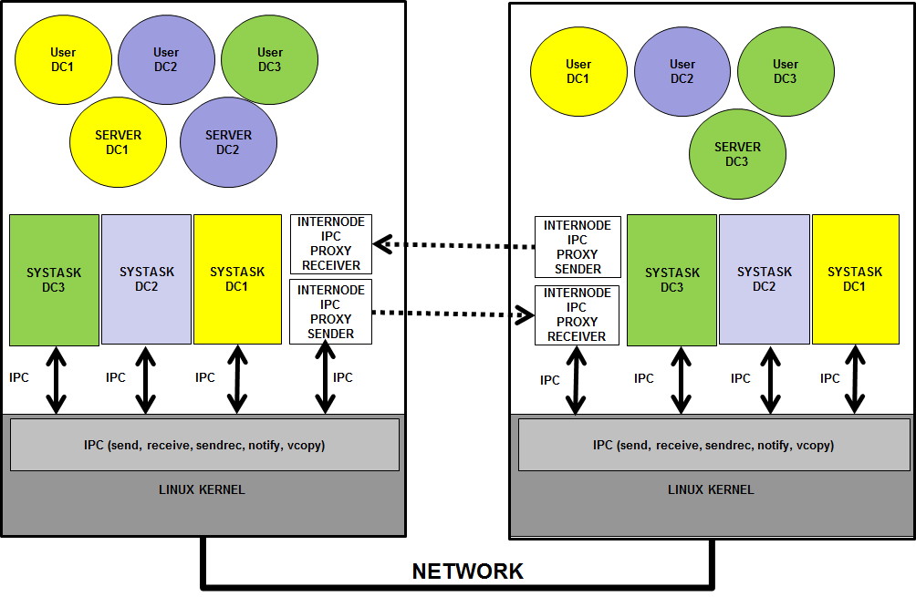
- DVS Proxies.

Proxies and Nodes dvk_calls related overview
The following dvk_calls are available to programmers to manage proxies and nodes:
dvk_proxies_bind()- Registers a pair of local processes as sender and receiver proxies to represent a remote node.
dvk_proxy_conn()- Changes the status of proxies connections.
dvk_proxies_unbind()- De-registers the sender and receiver proxies which represent a remote node.
dvk_getproxyinfo()-Gets status and parameter information of a pair of proxies.
dvk_add_node()- Adds a remote node to a DC, therefore remote endpoints of the DC in the remote nod could be bound in the local DVK.
dvk_del_node()- Removes a node from a DC, therefore all remote endpoints bound to the local DVK are unbound.
dvk_getnodeinfo()- Gets status and parameter information of a node.

dvk_proxies_bind()
int dvk_proxies_bind(name, pxid, int spid, int rpid)

This dvk_call registers a pair of process as the sender and receiver proxies of a node. The initial node status is PROXY_NOT_CONNECTED, therefore any communication cannot be done until it is connected. This function must be called with DVS administrator’s capabilities.
- name: is the text that identifies the proxy pair.
- pxid: is an identifier for the proxy pair.
- spid: the PID of the process or thread that will acts as the Sender Proxy.
- rpid: the PID of the process or thread that will acts as the Receiver Proxy.
Return codes:
- OK: The process unbinds without errors.
- EDVSPRIVILEGES: The caller’s euid does not have the required capabilities.
- EDVSDVSINIT: The DVS was not initialized.
- EDVSBADNODEID: Invalid nodeid number.
- EDVSNODEBUSY: The node already has two proxies registered.
- EDVSBADPID: The supplied PID process is not running.
- EDVSNOTDIR: A problem trying to create the /proc/dvs/<node_name> directory.
- EDVSBADF: A problem trying to create a file under the /proc/dvs/<node_name> directory.

dvk_proxy_conn()
int dvk_proxy_conn(int pxid, int status)

This dvk_call allows to sets the proxy pair status as:
- CONNECT_SPROXY
- CONNECT_RPROXY
- DISCONNECT_SPROXY
- DISCONNECT_RPROXY
It informs the DVK about proxies communications status. This dvk_call must be called with DVS administrator’s capabilities.
If the proxies status are set to CONNECT_SPROXY and CONNECT_RPROXY, data or message transfer to any remote endpoint of every DC located in that node could be made.
If the proxies status are set to DISCONNECT_SPROXY and DISCONNECT_RPROXY, every data or message transfer that involves any remote endpoint of every DC located in that node ends returning an error.
Return codes:
- OK: The process unbinds without errors.
- EDVSPRIVILEGES: The caller’s euid does not have the required capabilities.
- EDVSDVSINIT: The DVS was not initialized.
- EDVSBADNODEID: Invalid nodeid number.
- EDVSINVAL: The status is not PROXY_NOT_CONNECTED or PROXY_CONNECTED.
- EDVSNODEFREE: The node is free.
- EDVSNOPROXY: The proxies of the node are not running or registered.

dvk_proxy_unbind()
int dvk_proxy_unbind(int pxid)

This dvk_call de-registers a pair of proxies. Every pending data or message transfer that involves any remote endpoint of every DC located on a node reached by this proxy pair will return an error code. This dvk_call must be invoked with DVS administrator’s capabilities.
Every registered proxy that exits by its own or killed by a signal is de-registered by the DVK before exits. It also signals with SIGPIPE the other peer proxy. Therefore it is not necessary for a process to call dvk_proxy_unbind() to de-register itself.
Return codes:
- OK: The process unbinds without errors.
- EDVSPRIVILEGES: The caller’s euid does not have the required capabilities.
- EDVSDVSINIT: The DVS was not initialized.
- EDVSBADNODEID: Invalid nodeid number.

dvk_getproxyinfo
long dvk_getproxyinfo(int pxid, proc_usr_t *sproc_usr, proc_usr_t *rproc_usr)

This dvk_call gets status and configuration parameters of the processes registered as a proxy pair. It must be called with DVS administrator’s capabilities.
The proc_usr_t is defined as:
/* =================================*/
/* PROCESS DESCRIPTOR */
/* =================================*/
struct proc_usr {

int p_nr; /* process number */
int p_endpoint; /* process endpoint */
int p_dcid; /* process DCID */
volatile unsigned long p_rts_flags; /* process is runnable only if zero */
int p_lpid; /* local LINUX REAL PID in global namespace */
int p_vpid; /* local LINUX VIRTUAL PID in DC namespace */
int p_nodeid; /* Node ID where the process PRIMARY replica is running */
unsigned long p_nodemap; /* bitmap of nodes where replicas of this process exists UNTIL 32 NODES!!! */
// node_map_t p_nodemap; /* bitmap of nodes where replicas of this process exists */

volatile unsigned long p_misc_flags; /* miselaneous flags */

int p_getfrom; /* from whom does process want to receive? */
int p_sendto; /* to whom does process want to send? */
int p_waitmigr; /* waiting the migration of a process */
int p_waitunbind; /* waiting the unbinding of a process */
int p_proxy; /* the descriptor is enqueued on a proxy */
unsigned long p_lclsent; /* counter of LOCAL messages sent */
unsigned long p_rmtsent; /* counter of REMOTE messages sent */
unsigned long p_lclcopy; /* counter of LOCAL copies as source */
unsigned long p_rmtcopy; /* counter of REMOTE copies as source */

char p_name[MAXPROCNAME];

#ifdef DVS_USERSPACE
cpu_set_t p_cpumask;
#else
cpumask_t p_cpumask;
#endif

}; typedef struct proc_usr proc_usr_t;

dvk_add_node()
int dvk_add_node(int dcid, int nodeid)

This dvk_call registers a remote node to a DC telling that some process of that DC could run in that node. The node’s proxies must be registered before adding the node to a DC. It must be called with DC/VOS administrator’s capabilities.
Return codes:
- OK: The process unbinds without errors.
- EDVSPRIVILEGES: The caller’s euid does not have the required capabilities.
- EDVSDVSINIT: The DVS was not initialized.
- EDVSBADNODEID: Invalid nodeid number.
- EDVSNOPROXY: The node’s proxies have not been registered.
- EDVSDCNOTRUN: The DC is not running (init).
- EDVSDCNODE: The node is already included into the DC list of nodes.

dvk_ getnodeinfo()
long dvk_getnodeinfo(int nodeid, node_usr_t *node_usr_ptr)

This dvk_call gets status and configuration parameters of a node. It must be called with DVS administrator’s capabilities.
The node_usr_t is defined as:
struct node_usr {
int n_nodeid;
volatile unsigned long n_flags;
int n_proxies; /* proxies ID for this node */
unsigned long int n_dcs; /* DC BITMAP */
struct timespec n_stimestamp; /* timestamp of the last sent msg */
struct timespec n_rtimestamp; /* timestamp of the last received msg */
unsigned long n_pxsent; /* proxy message sent to that node */
unsigned long n_pxrcvd; /* proxy message received from the node */
char n_name[MAXNODENAME];
};
typedef struct node_usr node_usr_t;

The n_dcs field is a bitmap telling which DCs are located on the node.
Return codes:
- OK: The process unbinds without errors.
- EDVSPRIVILEGES: The caller’s euid does not have the required capabilities.
- EDVSDVSINIT: The DVS was not initialized.
- EDVSBADNODEID: Invalid nodeid number.

dvk_del_node()
int dvk_del_node(int dcid, int nodeid)

This dvk_call de-registers a remote node from a DC. Every pending communication with a DC’s endpoint that is located on that node is finished returning an error. It must be called with DC/VOS administrator’s capabilities.
Return codes:
- OK: The process unbinds without errors.
- EDVSPRIVILEGES: The caller’s euid does not have the required capabilities.
- EDVSDVSINIT: The DVS was not initialized.
- EDVSBADNODEID: Invalid nodeid number.
- EDVSBADDCID: The dcid of is out of range (0≤dcid<NR_DCS).
- EDVSNOPROXY: The node’s proxies have not been registered.
- EDVSDCNOTRUN: The DC is not running (init).
- EDVSDCNODE: The node is NOT included into the DC list of nodes.

dvk_node_up()
int dvk_node_up(char name[], int nodeid, int pxid)

This dvk_call links a node to the proxy pair. Every local data or message transfer to that node will be made through the mentioned proxy pair. It must be called with DC/VOS administrator’s capabilities.
Return codes:
- OK: The process unbinds without errors.
- EDVSPRIVILEGES: The caller’s euid does not have the required capabilities.
- EDVSDVSINIT: The DVS was not initialized.
- EDVSBADNODEID: Invalid nodeid number.
- EDVSPROXYFREE: The proxy pair is unused.

dvk_node_down()
int dvk_node_down(int nodeid)

This dvk_call unlinks a node from a proxy pair. It must be called with DVS administrator’s capabilities.
Return codes:
- OK: The process unbinds without errors.
- EDVSPRIVILEGES: The caller’s euid does not have the required capabilities.
- EDVSDVSINIT: The DVS was not initialized.
- EDVSBADNODEID: Invalid nodeid number.
- EDVSPROXYFREE: The proxy pair is unused.

dvk_get2rmt()
int dvk_get2rmt(cmd_t *header, proxy_payload_t *payload)

This dvk_call can only be used by a registered Sender Proxy. It is used to get a data block or a message from DVK to be sent to one of the remote nodes this proxy is linked to. It must be called with DVS administrator’s capabilities.
In the header structure there is information for the Sender Proxy about the kind of proxy message, and eventually, its payload.
struct cmd_s {
int c_cmd;
int c_dcid; /* DC ID */
int c_src; /* source endpoint */
int c_dst; /* destination endpoint */
int c_snode; /* source node */
int c_dnode; /* destination node */
int c_rcode; /* return code */
int c_len; /* payload len */
unsigned long c_flags; /* generic field for flags filled and controlled by proxies not by the DVK */
unsigned long c_snd_seq; /* send sequence # - filled and controlled by proxies not by the DVK */
unsigned long c_ack_seq; /* acknowledge sequence # - filled and controlled by proxies not by the DVK */
struct timespec c_timestamp; /* timestamp */
union {
vcopy_t cu_vcopy; /* struct used only for remote vcopy */
message cu_msg;
}c_u;
};
typedef struct cmd_s cmd_t;

The c_cmd field coud be:
enum proxy_cmd{
CMD_NONE = 0, /* NO COMMAND */
CMD_SEND_MSG, /* Send a message to a process */
CMD_NTFY_MSG, /* Send a NOTIFY message to remote proces */
CMD_SNDREC_MSG, /* Send a message to a process and wait for reply */
CMD_REPLY_MSG, /* Send a REPLY message to a process */
CMD_COPYIN_DATA, /* Request and DATA to copy data to remote process */
CMD_COPYOUT_RQST, /* The remote process send to local process the data requested */
CMD_COPYLCL_RQST,
CMD_COPYRMT_RQST, /* REQUESTER to SENDER to copy data out to RECEIVER */
CMD_COPYIN_RQST, /* SENDER to RECEIVER */
CMD_HELLO, /* HELLO COMMAND used by proxies */
CMD_SHUTDOWN, /* Exit the waiting loop with error EDVSINTR */
CMD_CHECKBIND, /* Request remote RPROXY if a REMOTE process is binded */
CMD_LAST_CMD /* THIS MUST BE THE LAST COMMAND */
};

Useful field for the Sender proxy will be:
- c_dcid: The DCID the message or data belongs to. The Sender proxy could use this information to apply QoS or filtering based on the DCID.
- c_src, c_dst: The Sender proxy could use this information to apply QoS or filtering based on source and/or destination endpoint.
- c_dnode: The Sender proxy could use this information to apply QoS or filtering or protocol selection, routing, etc. based on the destination node.
- c_len: Needed by the Sender proxy for message transfer.
- c_timestamp: The Sender proxy could use this information to apply QoS, filtering, delaying, ordering, etc. based on this field.
The payload could be a block of data or a batch of messages.
typedef union {
cmd_t pay_cmd[MAXBATCMD]; /* Proxies commands used to transport batched msgs */
char pay_data[MAXCOPYBUF]; /* buffer space to copy data */
} proxy_payload_t;

dvk_put2lcl()
int dvk_put2lcl(cmd_t *header, proxy_payload_t *payload)

This dvk_call can only be used by a registered Receiver Proxy. It is used to put a data block or send a message to a local process. It must be called with DVS administrator’s capabilities.
In the header structure is used by the local DVK to correct deliver. It should not be modified by the proxy, but it can change the delivery order or filter based of some of the header fields.

Fault Tolerance and Process Migration
Some fault tolerant applications use the Primary-Backup approach. The DVK supports IPC redirection when the Primary fails and one of the Backup processes (in other node) becomes the new Primary. Data and Messages will be redirected by all nodes to the node of the new Primary.
The DVK supports message redirection on node switching when a Primary process (on node A) is replaced by a Backup process (on node B). The local DVK automatically unlinks the endpoint from the previous primary process (on node A) and links it to the new primary process (on node B). The DVK supports that processes belonging to the same DC, but residing on different nodes of the cluster, can have the same endpoint numbers. Only one of that processes will be the primary endpoint and the others will be backup endpoints. If the primary process crashes, a high level application that detects the failure could designate one of the backup endpoints as the new primary. The switching of the primary process should be masked for those processes that were communicating with the former primary. The DVKs on the surviving nodes automatically unlink the endpoint from its previous node and then link it again, but to the new node, including if it is the own node.
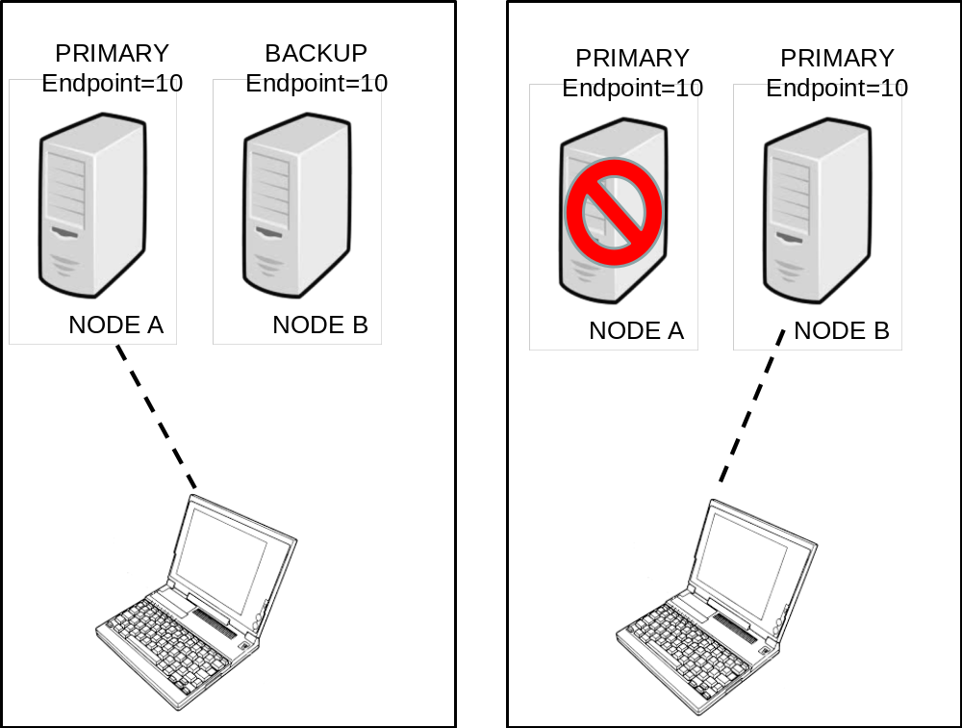
- Primary/Backup Replication Fault Tolerance.

A local process can be registered as a Backup of a remote Primary process by using dvk_bkupbind() with the same endpoint in the same DC as the Primary. All messages sent to that endpoint are sent to the Primary process on the remote node. The Backup process could not communicate with any other process using M3-IPC until it is converted into the Primary process. A privileged management application must use dvk_migr_start() followed by dvk_migr_commit() to convert a Backup process into a Primary one. Eventually, if a Backup process terminates its process descriptor is switched automatically as a Remote process descriptor referring to the location of the Primary endpoint. Message replication among Primary and Backup endpoints does not concern to M3-IPC. For co-located processes a Backup endpoint has the same behavior as a Remote endpoint. Therefore, every message sent by a local process addressed to that endpoint will be send to the Primary process.
The DVK can keep communications in operational state and can automatically redirect messages on live process migration. The M3-IPC APIs must transparently support timeframes in which a process runs in a source node, timeframes in which the process is migrating, and timeframes in which the process runs in the destination node.
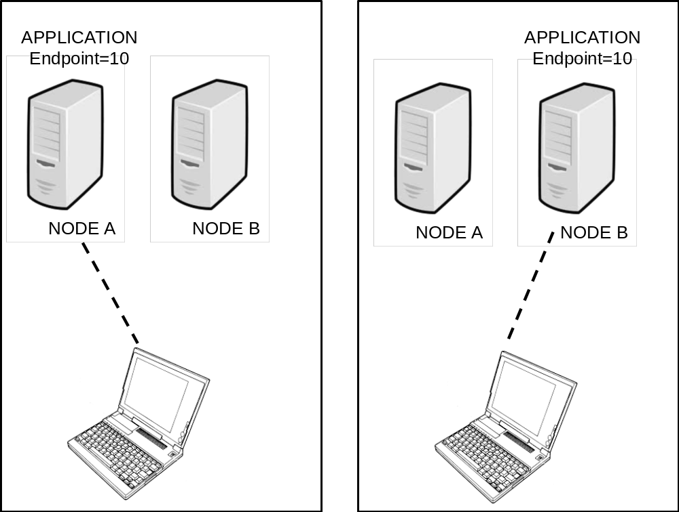
- Process Migration support.
Before a process begins to migrate, a management application must call dvk_migr_start(). At that moment, all messages addressed to the migrating endpoint will be queued up. Once the process has successfully migrated, the management application must call dvk_migr_commit(). All queued messages will be sent to the process on its new location. If migration fails, the management application must call dvk_migr_rollback(); then the process can resume its execution as if nothing had happened by receiving the queued messages.
Other fault tolerant applications use the State Machine approach. The DVK supports this kind of applications accepting several processes with the same endpoint running in different nodes. These endpoints must be of the Replicated class. The behavior with Replicated endpoints is the following:
- All local processes with Local endpoints will communicate with the Replicated endpoint in the same nodes.
- All processes with Local endpoints in other node will communicate with the Replicated endpoint bound as a Remote in their nodes.
In the sample presented in the following figure, Endpoint 10 is a Replicated Endpoint bound in two nodes, but in the same DC. Process with Local Endpoint=100 will communicate with process with Endpoint=10 in its own node (on Container-1). Process with Local Endpoint=200 will communicate with process with Endpoint=10 in its own node (on Container-2).
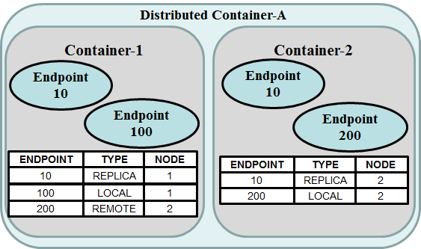
- State Machine Replication.
In the sample presented in the following figure, Endpoint 10 is a Replicated Endpoint bound in two nodes, but in the same DC.
- Process with Local Endpoint=200 will communicate with process with Endpoint=10 in its own node (on Container-2).
- Process with Local Endpoint=300 will communicate with process with Endpoint=10 in its own node (on Container-3).
- Process with Local Endpoint=100 in Container-1 will communicate with process with Endpoint=10 in its own node (on Container-3).
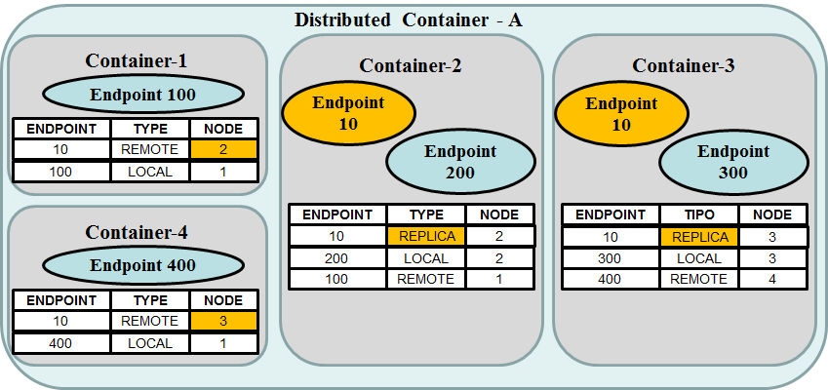
- Replicated State Machine load distribution.
If the process with Endpoint=10 con Container-2 fails, the administrator or a management application should call dvk_migr_start() on Container-1 and then dvk_migr_commit() pointing Remote Endpoint=10 to node-3. Then, on node-3 the management application must bind endpoint 100 to node-1 in node-3 as Remote.

dvk_migr_start()
int dvk_migr_start(int dcid, int endpoint)

This dvk_call stops all messages and data transfers addressed to the mentioned endpoint on the DC with dcid. It must be called with DC/VOS administrator’s capabilities.
Return codes:
- OK: Return without errors.
- EDVSPRIVILEGES: The caller’s euid does not have the required capabilities.
- EDVSDVSINIT: The DVS was not initialized.
- EDVSBADDCID: The dcid of is out of range (0≤dcid<NR_DCS).
- EDVSRANGE: Invalid endpoint.
- EDVSDSTDIED: The mentioned endpoint died.
- EDVSONCOPY: The mentioned endpoint is making a copy data and cannot be interrupted.
- EDVSBUSY: The mentioned endpoint is making a remote IPC and cannot be interrupted.
- EDVSENDPOINT: Bad endpoint.
- EDVSMIGRATE: The endpoint is already migrating.
- EDVSGRPLEADER: The endpoint is not registered by the main thread group leader.

dvk_migr_commit()
int dvk_migr_commit(int pid, int dcid, int endpoint, int node)

This dvk_call restarts all messages and data transfers addressed to the mentioned endpoint redirecting to the new node. If the new node for endpoint is the local node, the pid argument is the PID of the process on local node. It must be called with DC/VOS administrator’s capabilities.
Return codes:
- OK: Return without errors.
- EDVSPRIVILEGES: The caller’s euid does not have the required capabilities.
- EDVSDVSINIT: The DVS was not initialized.
- EDVSBADDCID: The dcid of is out of range (0≤dcid<NR_DCS).
- EDVSRANGE: invalid endpoint.
- EDVSNOPROXY: There is not a registered proxy pair for the mentioned node.
- EDVSDCNODE: The mentioned node is not valid for the DC.
- EDVSBADPID: The PID is invalid.

dvk_migr_rollback()
int dvk_migr_rollback(int dcid, int endpoint)

This dvk_call restarts all messages and data transfers addressed to the mentioned endpoint to the same node. It must be called with DC/VOS administrator’s capabilities.
Return codes:
- OK: Return without errors.
- EDVSPRIVILEGES: The caller’s euid does not have the required capabilities.
- EDVSDVSINIT: The DVS was not initialized.
- EDVSBADDCID: The dcid of is out of range (0≤dcid<NR_DCS).
- EDVSRANGE: invalid endpoint.
- EDVSONCOPY: The mentioned endpoint is making a copy data and cannot be interrupted.
- EDVSBUSY: The mentioned endpoint is making a remote IPC and cannot be interrupted.
- EDVSENDPOINT: Bad endpoint.
- EDVSMIGRATE: The endpoint is already migrating.
- EDVSGRPLEADER: The endpoint is not registered by the main thread group leader.
Backup endpoint use case : sample pseudocode
Primary Server on NODE A | Backup Server on NODE B | Client on NODE C
Before Failure and switching
svr_ep = dvk_bind(dcid,SVR_NR); | bk_ep = dvk_bkupbind ( dcid , getpid(),SVR_NR,node_A); | clt_ep = dvk_bind(dcid,CLT_NR);  svr_ep = dvk_rmtbind ( dcid, ”SERVER” , SVR_NR,node_A)
After Failure and switching
 | dvk_migr_start(dcid, bk_ep);  dvk_migr_commit (getpid(), dcid, bk_ep, node_B); | dvk_migr_start(dcid, svr_ep);  dvk_migr_commit( (-1), dcid, srv_ep, node_B);
Process Migration use case: sample pseudocode
Primary Server on NODE A | Backup Server on NODE B | Client on NODE C
Before Migration
svr_ep = dvk_bind(dcid,SVR_NR);  dvk_migr_start(dcid, svr_ep); | dvk_migr_start(dcid, bk_ep); | clt_ep = dvk_bind(dcid,CLT_NR);  svr_ep = dvk_rmtbind(dcid,”SERVER”, SVR_NR,node_A)  dvk_migr_start(dcid, svr_ep);
After successful Migration
 | dvk_migr_commit(getpid(), dcid, bk_ep, node_B); | dvk_migr_commit( (-1), dcid, srv_ep, node_B);
After failed Migration
dvk_migr_rollback(dcid, svr_ep); | dvk_migr_rollback(dcid, svr_ep); | dvk_migr_rollback(dcid, svr_ep);

Integration with Linux /proc filesystem
The DVS is integrated into the Linux kernel and with its /proc filesystem. Main DVS abstractions are represented by directories and files in /proc.
The DVS directories (/proc/dvs) have the following structure.
dvs
├── DC0
│ ├── info
│ ├── procs
│ └── stats
├── DC1
│ ├── info
│ ├── procs
│ └── stats
├── info
├── nodes
└── proxies
├── info
└── procs

The dvs directory is created by dvk_dvs_init(). It also creates the nodes and info files.
root@node0:/proc/dvs# ls -l
total 0
dr-xr-xr-x 2 root root 0 sep 20 19:45 DC0
dr-xr-xr-x 2 root root 0 sep 20 19:46 DC1
-r--r--r-- 1 root root 0 sep 20 19:45 info
-r--r--r-- 1 root root 0 sep 20 19:45 nodes
dr-xr-xr-x 2 root root 0 sep 20 19:45 proxies

The info file shows the parameter and status of the DVS.
root@node0:/proc/dvs# cat info
nodeid=0
nr_dcs=32
nr_nodes=32
max_nr_procs=221
max_nr_tasks=35
max_sys_procs=64
max_copy_buf=65536
max_copy_len=1048576
dbglvl=FFFFFFFF
version=2.1
sizeof(proc)=420
sizeof(proc) aligned=512
sizeof(dc)=156
sizeof(node)=92

The nodes file shows the parameter and status of the nodes and their proxies PIDs, which DCs are located on those nodes and other status flags.
root@node0:/proc/dvs# cat nodes
ID Flags Proxies -pxsent- -pxrcvd- 10987654321098765432109876543210 Name
0 6 -1 0 0 -------------------------------X node0
1 E 1 0 0 -------------------------------X node1
2 E 1 0 0 -------------------------------X node2

The function dvk_proxies_bind() binds a pair of processes to be used as the Sender and Receiver processes to the DVK.
root@node0:/proc/dvs/proxies# more procs
ID Type -lpid- -flag- -misc- -pxsent- -pxrcvd- -getf- -sendt -wmig- name
1 send 650 8 3 0 0 31438 27342 27342 tcp_proxy
1 recv 651 0 3 0 0 27342 27342 27342 tcp_proxy
2 send 652 8 3 0 0 31438 27342 27342 tcp_proxy
2 recv 653 0 3 0 0 27342 27342 27342 tcp_proxy

The function dvk_node_up() associates a pair of proxies to a node.
root@node0:/proc/dvs/proxies# more info
Proxies Flags Sender Receiver --Proxies_Name- 10987654321098765432109876543210
1 7 650 651 node1 ------------------------------X-
2 7 652 653 node2 -----------------------------X--

The dvk_dc_init() creates a directory with the DC name and the status, procs and info files under it.
root@node0:/proc/dvs/proxies# cd ..
root@node0:/proc/dvs# cd DC0/
total 0
-r--r--r-- 1 root root 0 sep 20 19:46 info
-r--r--r-- 1 root root 0 sep 20 19:46 procs
-r--r--r-- 1 root root 0 sep 20 19:46 stat

The info file shows the parameter and status of the DC, and in which nodes the DC are located.
root@node0:/proc/dvs/DC0# more info
dcid=0
flags=0
nr_procs=221
nr_tasks=35
nr_sysprocs=64
nr_nodes=32
dc_nodes=3
dc_pid=645
warn2proc=27342
warnmsg=0
dc_name=DC0
nodes 33222222222211111111110000000000
10987654321098765432109876543210
------------------------------XX
cpumask=1

The proc file shows the parameter and status of the process endpoints of the DC and in which nodes they reside. If the endpoint is located in the local node, its PID is shown.
root@node0:/proc/dvs/DC0# more procs
DC pnr -endp -lpid/vpid- nd flag misc -getf -sndt -wmig -prxy name
0 0 0 662/2 0 8 20 31438 27342 27342 27342 loop_r-s_server
0 1 1 -1/-1 1 1000 0 27342 27342 27342 27342 client1
0 2 2 663/3 0 8 20 3 27342 27342 27342 loop_r-s_server
0 3 3 -1/-1 1 1000 0 27342 27342 27342 27342 client3

The lpid/vpid column are the Linux global/init PID and Virtual PID of the process in the local node.
root@node0:/proc/dvs/DC0# more stats
DC pnr -endp -lpid/vpid- nd --lsnt-- --rsnt-- -lcopy-- -rcopy-- name
0 0 0 662/ 2 0 1 0 0 0 loop_r-s_server
0 1 1 -1/ -1 1 0 0 0 0 client1
0 2 2 663/ 3 0 1 0 0 0 loop_r-s_server
0 3 3 -1/ -1 1 0 0 0 0 client3

The dvk_proxy_bind() register a node and creates a directory with the name of the node and the info and stats files under it.
root@node0:~# cat /proc/dvs/proxies/info
Proxies Flags Sender Receiver --Proxies_Name- 10987654321098765432109876543210
1 1 576 578 node1 ------------------------------X-
2 1 581 582 node2 -----------------------------X--
3 1 574 575 node3 ----------------------------X---
4 1 579 580 node4 ---------------------------X----
5 1 583 584 node5 --------------------------X-----
6 1 586 587 node6 -------------------------X------
7 1 588 589 node7 ------------------------X-------
8 1 591 592 node8 -----------------------X--------
9 1 594 595 node9 ----------------------X---------
10 1 599 600 node10 ---------------------X----------
11 1 597 598 node11 --------------------X-----------
12 1 603 604 node12 -------------------X------------

root@node0:~# cat /proc/dvs/proxies/procs
ID Type -lpid- -flag- -misc- -pxsent- -pxrcvd- -getf- -sendt -wmig- name
1 send 576 0 1 0 0 27342 27342 27342 tcp_proxy
1 recv 578 0 1 0 0 27342 27342 27342 tcp_proxy
2 send 581 0 1 0 0 27342 27342 27342 tcp_proxy
2 recv 582 0 1 0 0 27342 27342 27342 tcp_proxy
3 send 574 0 1 0 0 27342 27342 27342 tcp_proxy
3 recv 575 0 1 0 0 27342 27342 27342 tcp_proxy
4 send 579 0 1 0 0 27342 27342 27342 tcp_proxy
4 recv 580 0 1 0 0 27342 27342 27342 tcp_proxy
5 send 583 0 1 0 0 27342 27342 27342 tcp_proxy
5 recv 584 0 1 0 0 27342 27342 27342 tcp_proxy
6 send 586 0 1 0 0 27342 27342 27342 tcp_proxy
6 recv 587 0 1 0 0 27342 27342 27342 tcp_proxy
7 send 588 0 1 0 0 27342 27342 27342 tcp_proxy
7 recv 589 0 1 0 0 27342 27342 27342 tcp_proxy
8 send 591 0 1 0 0 27342 27342 27342 tcp_proxy
8 recv 592 0 1 0 0 27342 27342 27342 tcp_proxy
9 send 594 0 1 0 0 27342 27342 27342 tcp_proxy
9 recv 595 0 1 0 0 27342 27342 27342 tcp_proxy
10 send 599 0 1 0 0 27342 27342 27342 tcp_proxy
10 recv 600 0 1 0 0 27342 27342 27342 tcp_proxy
11 send 597 0 1 0 0 27342 27342 27342 tcp_proxy
11 recv 598 0 1 0 0 27342 27342 27342 tcp_proxy
12 send 603 0 1 0 0 27342 27342 27342 tcp_proxy
12 recv 604 0 1 0 0 27342 27342 27342 tcp_proxy

In NODE0 with TCP proxies for 12 nodes, the receiver TCP sessions could be checked with netstat command. The local TCP port number in which the receiver proxy listens is (3000+rmt_nodeid)

root@node0:~# netstat -nat
Active Internet connections (servers and established)
Proto Recv-Q Send-Q Local Address Foreign Address State
tcp 0 0 0.0.0.0:3001 0.0.0.0:* LISTEN
tcp 0 0 0.0.0.0:3002 0.0.0.0:* LISTEN
tcp 0 0 0.0.0.0:3003 0.0.0.0:* LISTEN
tcp 0 0 0.0.0.0:3004 0.0.0.0:* LISTEN
tcp 0 0 0.0.0.0:3005 0.0.0.0:* LISTEN
tcp 0 0 0.0.0.0:3006 0.0.0.0:* LISTEN
tcp 0 0 0.0.0.0:3007 0.0.0.0:* LISTEN
tcp 0 0 0.0.0.0:3008 0.0.0.0:* LISTEN
tcp 0 0 0.0.0.0:3009 0.0.0.0:* LISTEN
tcp 0 0 0.0.0.0:3010 0.0.0.0:* LISTEN
tcp 0 0 0.0.0.0:3011 0.0.0.0:* LISTEN
tcp 0 0 0.0.0.0:3012 0.0.0.0:* LISTEN

Once the proxies end, DC ends, or DVS ends, the related directories and files are removed.

How to start a DC ?
This is a sample script to load the DVK module, to start de DVS, initialize de DC, start a proxy and adding a node to a DC.

#!/bin/bash
if [ $# -ne 2 ]
then
echo "usage: $0 <lcl_nodeid> <dcid>"
exit 1
fi
lcl=$1
let rmt=(1 - $lcl)
dcid=$2
echo "lcl_nodeid=$lcl dcid=$dcid"
read -p "Enter para continuar... "

dmesg -c > /dev/null
mknod /dev/dvk c 33 0 THIS DEVICE WILL BE USED BY THE DVK
cd /usr/src/dvs/dvk-mod
dmesg -c > /usr/src/dvs/dvk-tests/dmesg.txt
insmod dvk.ko dvk_major=33 dvk_minor=0 dvk_nr_devs=1 DVK MODULE LOAD
dmesg -c > /usr/src/dvs/dvk-tests/dmesg.txt

cd /usr/src/dvs/dvk-tests
read -p "local_nodeid=$lcl Enter para continuar... "
./test_dvs_init -n $lcl -D 16777215 DVS INITIALIZATION
read -p "DC$dcid Enter para continuar... "

./test_dc_init -d $dcid DC INITIALIZATION
dmesg -c >> /usr/src/dvs/dvk-tests/dmesg.txt

read -p "TCP PROXY Enter para continuar... "
# PARA DESHABILITAR EL ALGORITMO DE NAGLE!!
echo 1 > /proc/sys/net/ipv4/tcp_low_latency
echo 0 > /proc/sys/kernel/hung_task_timeout_secs
cd /usr/src/dvs/dvk-proxies
./tcp_proxy node$rmt $rmt >node$rmt.txt 2>error$rmt.txt & TCP PROXY START
sleep 5
read -p "Enter para continuar... "
cat /proc/dvs/nodes
cat /proc/dvs/proxies/info
cat /proc/dvs/proxies/procs

read -p "ADDNODE Enter para continuar... "
cd /usr/src/dvs/dvk-tests
cat /proc/dvs/DC$dcid/info
./test_add_node $dcid $rmt ADDING A REMOTE NODE TO THE DC
sleep 1
cat /proc/dvs/nodes
cat /proc/dvs/DC$dcid/info
exit

How to run a process inside a DC?
The previous script has a output file with a shell called <DC_name>.sh, for example “DC0.sh”
Then, the administrator mas execute # . ./DC0.sh . Pay attention to the two separated dots, this means that the current shell will not create a child shell to execute the script, it will be executed by itself. In this example, the DC0.sh setups an environment variable an exports it as follows.
# export DC0=<DC_control_PID>

Where DC_control_PID will be the PID of the first process inside the namespace of the DC.
To run other processes inside the same DC, this control process must invoke them or an external process will execute:
# nsenter -p -t$DC0 <program and arguments>

To execute the command with another EUID.
# nsenter -p -t$DC0 -S 1000 <program and arguments> # where 1000 UID of the user

If no program is specified in the nsenter command, the shell will be executed inside the DC namespace.
The PIDs of the processes inside the DC namespace differ from those of the init or global namespace. This can be tested making ps –ef inside and outside the DC namespace.

Source Code Organization
The source code is organized as it is presented in the following graph.
dvs
├── chardev-ioctl << example of a character device and IOCTL usage
├── dvk-lib << library of dvk_calls
├── dvk-loops << series of microbenchmarks for local IPC
├── dvk-mod << the dvk kernel module
├── dvs-apps << Native DVS applications
├── dvk-proxies << proxies
│ └── test << microbenchmarks for remote IPC
├── dvk-tests << dvk_calls test programs
├── vos << dvk_calls test programs
│ ├── uk << unikernel VOS source code
│ └── mol << MoL source code
├── include
│ ├── com << common header files (for kernel, lib, userapps)
│ ├── dvk << header only used by the dvk
│ └── dvs << to be used other dvs header files
├── lkm_example << example of kernel module
├── lz4-1.8.2 << LZ4 to be used by proxies, VOS or applications.
├── reljmp-master << example to get unpublished kernel functions and vars
├── linux-4.9.88 << Linux kernel modified source programs
└── spread-src-5.0.1 << the spread toolkit

The source code of the DVS is below dvs directory. Only the directory linux-4.9.88 has not significance because it has the modified Linux kernel sources required by the DVS.
The dvs directory has several sub-directories.
The dvk-lib has the dvk_call libraries to link with management and application code. The dvk-tests directory has several DVK testing code.
The dvk-loops directory has several micro-benchmarks to test M3-IPC local performance.
The dvk-proxy directory has reference source code for proxy servers based on UDP, TCP and TIPC. It also has a test directory with several benchmarks to test remote IPC.

How to add a new dvk_call
To add a new dvk_call several files must be changed.
The dvk_dummy() will be used as sample with two arguments. The function must be defined in one of the source files in the dvk-mod directory. For this sample, it is defined in the dvk_hyper.c

/*--------------------------------------------------------------*/
/* new_dummy */
/*--------------------------------------------------------------*/

asmlinkage long new_dummy(int arg1, int arg2)
{
DVKDEBUG(DBGPARAMS,"arg1=%d arg2=%d\n", arg1, arg2);
// source code here
}

dvs/include/com/dvk_calls.h
BEFORE
#define DVK_WAKEUPEP 34
#define DVK_NR_CALLS 35

AFTER
#define DVK_WAKEUPEP 34
#define DVK_DUMMY 35
#define DVK_NR_CALLS 36

dvs/include/com/dvk_ioctl.h
// TWO PARAMETERS
#define DVK_IOCSRCVRQST _IOW(DVK_IOC_MAGIC, DVK_RCVRQST, int)
#define DVK_IOCSDUMMY _IOW(DVK_IOC_MAGIC, DVK_DUMMY, int)

dvs/include/com/stub_dvkcall.h
long dvk_dummy (int arg1, int arg2);

dvs/dvk-mod/dvk_ioproto.h
long io_dummy (unsigned long arg);

dvs/dvk-mod/dvk_newproto.h
asmlinkage long new_dummy (int arg1, int arg2);

dvs/dvk-lib/stub_dvkcall.c
long dvk_dummy(int arg1, int arg2)
{
long ret;
parm_dummy_t parm;
LIBDEBUG(DBGPARAMS, "arg1=%d arg2=%d\n", arg1, arg2);
parm.ag1 = arg1;
parm.ag2 = arg2;
ret = ioctl(dvk_fd, DVK_IOCSDUMMY , (int) &parm);
LIBDEBUG(DBGPARAMS,"ioctl ret=%d errno=%d\n",ret, errno);
if (ret < 0) ERROR_RETURN(-errno);
errno = 0;
return(ret);
}

dvs/dvk-mod/dvk_decode.c
struct parm_dummy_s {
int ag1;
int ag2;
};
typedef struct parm_dummy_s parm_dummy_t;

dvs/dvk-mod/dvk_decode.c
long io_dummy(unsigned long arg)
{
parm_dummy_t dp;
long rcode=0;
DVKDEBUG(DBGPARAMS,"\n");
rcode = copy_from_user( (void*) & dp, (const void __user *) arg, sizeof(parm_dummy_t));
if(rcode) ERROR_RETURN(EDVS2BIG);
rcode = new_dummy(dpd.ag1, dpd.ag2);
return(rcode);
}

The path to execute a dvk_call is the following:
- The program calls dvk_dummy() with two arguments.
- The dvk_dummy() function is defined in the libdvklib.so library.
- If the function needs to pass only one parameter, it will be used in the ioctl() call.
- If the function needs to pass more than one parameter it must need to fill a specific structure defined for this dvk_call, in this case parm_dummy_t.
- Then the ioctl() function is called with one argument, the only parameter of the function or the address of the parameter structure defined for the new dvk_call.
- The kernel function ioctl()calls the dvk_ioctl () function of the DVK module which calls the required dvk_call, in this example io_dummy().
- io_dummy() copy the userspace arguments in the structure to the same structure but in the kernel, then call the kernel function in the kernel module new_dummy().

Kernel and Module Compilation and Deployment
To build the new kernel the user root must execute:
sudo make -j 4 && sudo make modules_install -j 4 && sudo make install -j 4
update-initramfs -c -k 4.9.88
update-grub
update-grub2

To build the new kernel module the user root must execute:
# cd /usr/src/dvs
# cd dvk_lib
# make clean; make
# cd dvk_mod
# make clean; make
To test the new dvk_call, in the dvk-tests directory create the test_dummy.c

#include "tests.h"

void main ( int argc, char *argv[] )
{
int ret;

if ( argc != 3) {
fprintf(stderr, "Usage: %s <arg1> <arg2> \n", argv[0] );
exit(EXIT_FAILURE);
}

ret = dvk_open();
if (ret < 0) ERROR_EXIT(ret);

ret = dvk_dummy(atoi(arg[1]), atoi(arg[2]));
ERROR_PRINT(ret);

exit();
}

